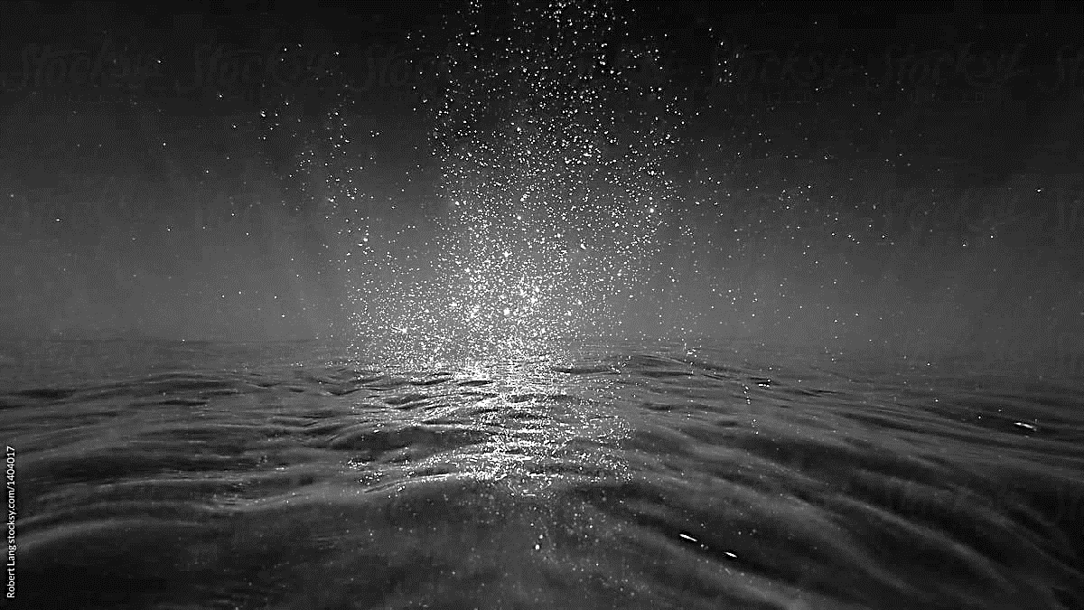

Purification and Dispatch Centres
Fish Health Approval

Application Form

Introduction to Fish Health Regulations
The Marine Institute is the Competent Authority in Ireland responsible for the implementation of EU Regulation 2016/429 which deals with the health of aquaculture animals and the prevention and control of certain aquatic diseases.

Fish Health Approval
Under Article 176(1) of Regulation (EU) 2016/429, purification centres and dispatch centres for live molluscs are considered to be aquaculture establishments, therefore requiring approval by the Fish Health Unit, Marine Institute.

Completed Applications should be returned by Email or Post to:
Competent Authority, Fish Health Unit, Marine Institute,
Rinville, Oranmore, Co. Galway
Email: notification@marine.ie

For Further Information or Assistance Please Contact
the Fish Health Unit at:
Email: notification@marine.ie
Phone: 00 353 (0) 91 387200
or visit our site at:
www.fishhealth.ie

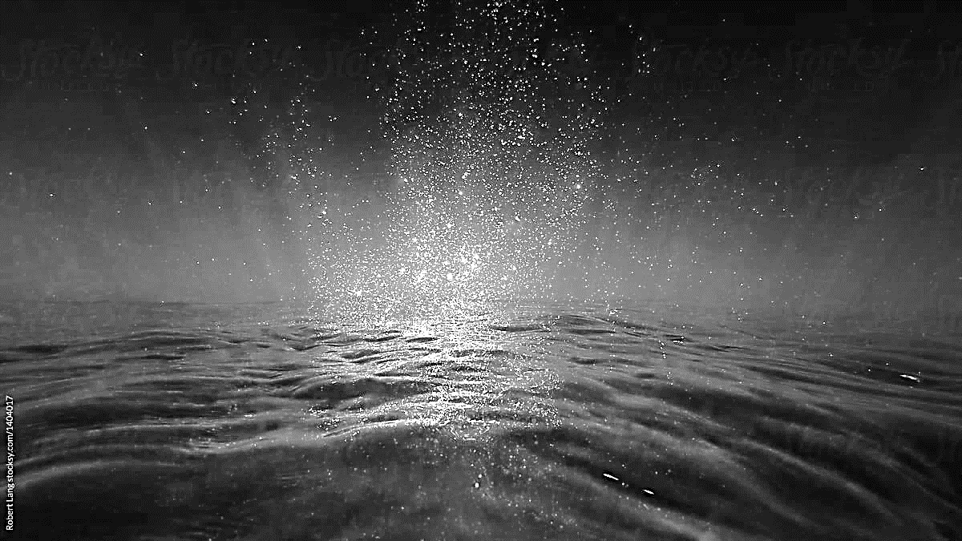
- Particulars of Business

TRADE NAME

TRADE ADDRESS

(include postcode)
CONTACT DETAILS | Landline: |  | Mobile:
 | Email:
BUSINESS STATUS  (Please Tick Relevant Box) | Limited Company [Registered business with limited liability for all members]  Sole Trader [Unincorporated business with one owner or jointly owned by a married couple]  Partnership [Unincorporated business with two or more owners]  Cooperative [Private organisation owned and controlled by a group of individuals for their own benefit]
BUSINESS STATUS  (Please Tick Relevant Box) | Other
BUSINESS STATUS  (Please Tick Relevant Box) | Merger Details:  (if any)
REGISTERED OFFICE ADDRESS
(if different from the trade address outlined above)

- Particulars of Applicant

NAME OF APPLICANT

ADDRESS OF APPLICANT
(include postcode)
CONTACT DETAILS | Landline: |  | Mobile:
CONTACT DETAILS | Email:

CONTACT NAME FOR ALL CORRESPONDENCE

ADDRESS TO WHICH ALL CORRESPONDENCE SHOULD BE SENT

DO YOU CURRENTLY HOLD FHA FOR ANOTHER AQUACULTURE PRODUCTION BUSINESS?

(if yes please provide FHA number)

- Details of Purification / Dispatch Centre

ADDRESS OF PURIFICATION/DISPATCH CENTRE (include postcode)
TYPE OF ACTIVITY | Purification  Dispatch  Both Purification and Dispatch
SPECIES KEPT ON SITE
DETAILS OF WATER SUPPLY SOURCE | Marine (Bay)  River  Mains Supply (artificial seawater)
DETAILS OF WATER SUPPLY SOURCE | Other:
NAME SOURCE OF WATER SUPPLY (if different from location of establishment)
DETAILS OF WHERE WASTE WATER FROM YOUR ESTABLISHMENT IS DISCHARGED TO | Marine (Site)  River  Groundwater  Sewer Network
 | Other:
NAME LOCATION OF WASTE WATER DISCHARGE (if different from location of establishment)
DETAILS OF WASTE WATER TREATMENT | None  UV Light  Chemical  Filtration
DETAILS OF WASTE WATER TREATMENT | Other:
LIST ALL SOURCES THROUGH WHICH YOU RECEIVE MOLLUSCS TO YOUR ESTABLISHMENT
ARE YOU REGISTERED WITH THE SFPA AS AN APPROVED PURIFICATION AND/OR DISPATCH CENTRE | Yes  No

Declaration by Applicant

I declare that, all particulars supplied in this Application Form and in the Biosecurity Plan which accompanies it, provide accurate details about the establishment(s) which I/we operate.

Signature of Applicant:

Date

Name (in block capitals)

Position

