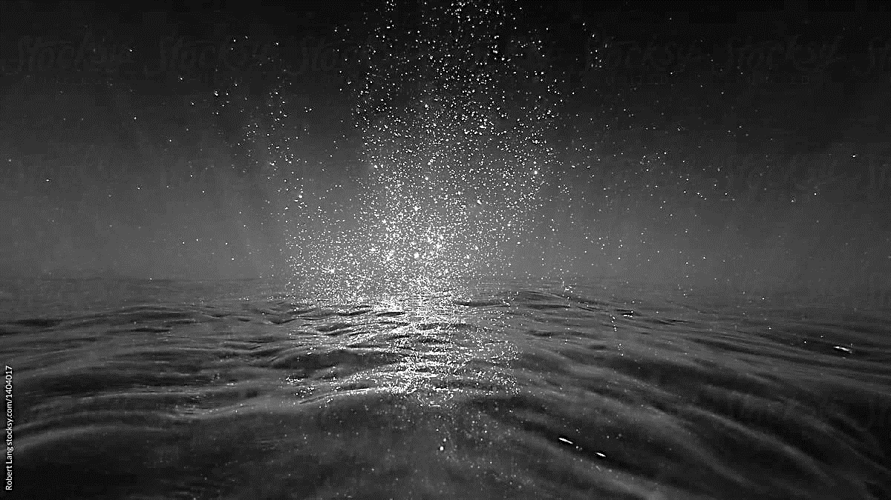
Treatment / Harvest Vessels

Application for fish health approval

Background
The Marine Institute is the Competent Authority responsible for the implementation of the aquatic elements of Regulation EU 2016/429 (Animal Health Law (AHL)) and it’s supplementing delegated and implementing Regulations. Those Regulations set out certain rules concerning the operation of vessels where animals are kept temporarily to be treated or to undergo other husbandry related procedures, including the requirement for such vessels to be approved by the Competent Authority.

Who should apply for vessel fish health approval?

According to Article 4 (e) of Regulation (EU) 2020/691, operators of vessels or other mobile premises where aquaculture animals are kept temporarily to be treated or undergo another husbandry related procedure, are required to apply to the Competent Authority for approval in accordance with Article 176(1)(b) of Regulation (EU) 2016/429. Operationally, in Ireland, this obligation applies to operators of vessels which are used for the treatment and harvest of aquaculture animals.

What specific requirements apply to operators of approved vessels?

In order for the vessels referred to above to be approved, they must comply with the following Articles of Regulation (EU) 2020/691:

- Article 19, with reference to Annex I, point 1 of Part 12 in relation to biosecurity measures, and point 2 of Part 12 in relation to facilities and equipment;

- Article 34 concerning record keeping obligations.


- Particulars of Business

TRADE NAME

TRADE ADDRESS
CONTACT DETAILS | Landline: |  | Mobile:
 | Email:
BUSINESS STATUS  (Please Tick Relevant Box) | Limited Company Partnership  Sole Trader Cooperative
BUSINESS STATUS  (Please Tick Relevant Box) | Other
REGISTERED OFFICE ADDRESS
(if different from the trade address outlined above)
NAME OF APPLICANT

ADDRESS OF APPLICANT
CONTACT DETAILS | Landline: |  | Mobile:
CONTACT DETAILS | Email:

CONTACT NAME FOR ALL CORRESPONDENCE

ADDRESS TO WHICH ALL CORRESPONDENCE SHOULD BE SENT
(if different from the Registered Office Address outlined above)

- Provide Details of Vessel

NAME OF VESSEL

WELL CAPACITY OF VESSEL/ HOLDING TANK (if applicable)

REGISTRATION NUMBER OF VESSEL (IMO Number)

- Provide Details of Vessel Operations

IDENTIFY VESSEL USE  (Please Tick Relevant Box) | Treatment Vessel  Harvest Vessel
IDENTIFY VESSEL USE  (Please Tick Relevant Box) | Other  (including occasional transport, please specify)
SPECIFY TREATMENT TYPE  (Please Tick Relevant Box  - if applicable) | Thermolicer  Hydrolicer  Freshwater Treatment
Other
(please specify)
HARVEST OPERATIONS

(Provide details of harvesting locations and procedures involved – if applicable)

AQUACULTURE ANIMALS
(Provide details of species & estimation of quantities of fish that may be treated/harvested at any given time)
WATER SUPPLY
(Provide details of where/when water is taken on-board and subsequently discharged from the vessel)

- Additional Application Requirements

- You must submit a documented Biosecurity Plan in accordance with Article 5 of Regulation EU 2020/691 to support your application for fish health approval.

The Biosecurity Plan must:

- identify the routes whereby a disease agent can enter the vessel, spread within it and transfer from it to the environment or to other aquaculture establishments;
- take into account the specificities of the vessel and identify risk-mitigation measures for each biosecurity risk that has been identified;
- include specific details of cleaning and disinfection processes that are carried out on the vessel, before it moves to another aquaculture establishment. In particular, the Biosecurity Plan must confirm that Stages 1, 2 and 3 cleaning and disinfection will be carried out in accordance with Annex I to this document;
- include details of any additional cleaning and disinfection procedures that apply to specialised equipment/ clothing/ footwear which are used during treatment/ harvesting events;
- where relevant, include procedures to validate the efficacy of automated cleaning and disinfection systems, before their initial use and at appropriate frequencies thereafter;
- include procedures concerning visitors to the vessel;
- detail procedures for the removal of dead animals, as well as procedures for the disposal of animal by-products.
- take into account that water exchanges can only take place at a distance of 10km or more, from the nearest aquaculture establishment.
- take into account that any bloodwater arising from harvesting/ dead haul of fish is treated in compliance with Regulation (EC) No. 1069/2009.

- You must submit details of the records that will be kept in compliance with Article 186(1) of Regulation (EU) 2016/429 and Article 34 of Regulation (EU) 2020/691, to support your application. This should include details of how you intend to keep the following records:

- the name, address and approval number of each aquaculture establishment where aquaculture animals are loaded for treatment/ harvest;
- dates and times of loading animals at the aquaculture establishment;
- the species, numbers, weights of aquaculture animals treated/ harvested during a given treatment/ harvesting event;
- dates and places at which the vessel was filled with water before loading and where relevant, exchanged between loading and unloading;
- details of the nature of each treatment or husbandry-related procedure which takes place at the vessel;
- where relevant, movements of aquaculture animals and products, including their places of origin and destination, the date of the movement and a link to any animal health certificate that relates to the movement;
- any mortality associated with a treatment event;
- concerning vessels where automated cleaning and disinfection systems are used, records including dates and other relevant information verifying the initial validation of the system, as well as details of ongoing maintenance and re-validation.

Declaration by Applicant

I declare that all particulars supplied in this Application Form and in the Biosecurity Plan and record keeping information which accompany it, provide accurate details about the vessels(s) which I/we operate, as well as the biosecurity measures that are implemented and the records that are kept.

Signature of Applicant:

Date

Name (in block capitals)

Position

ANNEX I
A. Stages of Cleaning and Disinfection

Stage | Under which circumstances should the stage be completed: | What does it entail: | Discharge of water during the cleaning & disinfection process:
1. | Stage 1 cleaning must be completed after every treatment or harvest event, and before contact with a new stock of fish.  Stage 1 is the basis for Stages 2 and 3. | Effective cleaning of the items listed in Part C.2.1. of Annex I | Water taken up at the site for cleaning, should either be discharged at the site, or at least 10km away from another active aquaculture establishment.
2. | At a minimum, Stage 2 cleaning & disinfection must be completed before a vessel:  - leaves a site in Ireland which is experiencing increased mortality;  - moves between aquaculture sites in Ireland *.  *When shuttle runs are required to move a particular cohort of fish from one bay to another, Stage 2 is carried out before the first run, then at a minimum, Stage 1 cleaning is carried out after each subsequent run, until such time as the entire cohort of fish has been moved. | Complete Stage 1, and effective disinfection of the items listed in Part C.2.2. of Annex I | Water taken up at the site for disinfection, should either be discharged at the site, or at least 10km away from another active aquaculture establishment.
3. | Stage 3 cleaning & disinfection including the hull must be completed before a vessel, which has come from abroad, commences work on an aquaculture establishment in Ireland.  Once a Stage 3 cleaning & disinfection has been completed, the vessel should steer a course which keeps it at least 10km from the nearest aquaculture establishment, until it arrives at its destination. If this distance is not achievable, the vessel should maintain closed valve status (including ballast water), and steer a course at least 5km from the nearest aquaculture establishment. | Complete Stages 1 and 2, and slipping of the vessel, to ensure the hull below the waterline is cleaned and disinfected. | Stage 3 cleaning and disinfection can be performed at a port which is at least 10km from an active aquaculture establishment.

B. Paperwork and Notification Required

Stage | Approved by | Notify the Marine Institute
1. | Vessel cleaning checklist (Part C.2.1. of Annex I) completed and signed off by the Operator of the vessel and witnessed by another crew member (Part C.3. of Annex I).  The Operator of the vessel should retain a log of cleaning agents used on board and the dates on which those processes are carried out. | Not required when the vessel has already been working within Ireland.  When coming from abroad, submit Part C.3. of Annex I to the Marine Institute at notification@marine.ie with evidence of completion of Stages 2 & 3 at least 48 working hours before the vessel arrives in Ireland.
2. | Vessel disinfection checklist (Part C.2.2. of Annex I) completed and signed off by the Operator of the vessel and witnessed by another crew member (Part C.4. of Annex I).  The Operator of the vessel should retain a log of disinfectants used on board and the dates on which those processes are carried out.  In addition, for vessels which have already been working in Ireland, before the vessel commences operations, the Fish Health Manager/Biologist of the site where the vessel is to be used must:  - be satisfied that cleaning and disinfection has been completed thoroughly. This includes checking the detailed records of cleaning and disinfection which are provided by the Operator of the vessel, and the completion of a sufficient number of swab checks of relevant parts of the vessel to ensure the biosecurity measures employed at the site are not jeopardised;  - visually check the hull of the vessel to ensure it is not heavily biofouled;  - sign Part C.5 of Annex I and complete the Farm Checklist for Vessels before the vessel can commence site operations; | Not required when the vessel has already been working within Ireland.  When coming from abroad, submit Part C.4. of Annex I to the Marine Institute at notification@marine.ie with evidence of completion of Stages 1 & 3 at least 48 working hours before the vessel arrives in Ireland.

Stage | Approved by | Notify the Marine Institute
3. | Cleaning and disinfection must be supervised by a veterinarian. Part C.6. of the Marine Institute’s Cleaning and Disinfection Declaration (C-038) must be completed once the veterinarian is satisfied that all 3 stages of cleaning and disinfection have been appropriately executed and fully completed.  The Operator of the vessel should retain a log of cleaning, disinfecting and slipping the vessel and the dates on which those processes are carried out.  In addition, for vessels coming to Ireland from abroad, before the vessel commences operations, the Fish Health Manager/Biologist of the site where the vessel is to be used, must:  - be satisfied that cleaning and disinfection has been completed thoroughly. This includes checking the detailed records of cleaning and disinfection which are provided by the Operator of the vessel, and the completion of a sufficient number of swab checks of relevant parts of the vessel to ensure the biosecurity measures employed at the site are not jeopardised;  - visually check the hull of the vessel to ensure it is not heavily biofouled;  - sign Part C.5 of Annex I and complete the Farm Checklist for Vessels before the vessel can commence site operations. | When coming from abroad, submit Part C.6. of Annex I to the Marine Institute at notification@marine.ie with evidence of completion of Stages 1, 2 & 3 at least 48 working hours before the vessel arrives in Ireland from abroad.

C. Cleaning and Disinfection Declaration (C-038)

C.1. PRODUCT / EQUIPMENT DETAILS:
Name of detergent used
Water Temperature used
Name & concentration of disinfectant used
Other equipment used (specify)

C.2. CLEANING & DISINFECTION CHECKLIST:
C.2.1.  STAGE 1 CLEANING | TICK | C.2.2.  STAGE 2 DISINFECTION | TICK
Hull above waterline |  | Hull above waterline
Wells |  | Wells
Grid plates |  | Grid plates
Pumps (incl. vacuum pump |  | Pumps (incl. vacuum pump
Bilge pumps |  | Bilge pumps
Sea valves |  | Sea valves
Deck |  | Deck
Railings |  | Railings
Bulkhead/casings |  | Bulkhead/casings
Hatches and covers |  | Hatches and covers
Derrick |  | Derrick
Crane |  | Crane
Ladders |  | Ladders
Counting Table |  | Counting Table
Ballast Tanks |  | Ballast Tanks
Protective clothing & boots |  | Protective clothing & boots
Date Completed |  | Date Completed

C.3. DECLARATION TO BE COMPLETED BY OPERATOR OF VESSEL AFTER STAGE 1 CLEANING:
I, …………………………………. Operator of the ……………………………………………have overseen the cleaning procedures outlined above and can confirm that they have been carried out in accordance with the requirements of the Marine Institute.
SIGNED: ____________________________ DATE: ______________________
WITNESSED: _________________________ DATE: ______________________

C.4. DECLARATION TO BE COMPLETED BY OPERATOR OF VESSEL AFTER STAGE 2 DISINFECTION:
I, …………………………………. Operator of the ……………………………………………have overseen the disinfection procedures outlined above and can confirm that they have been carried out in accordance with the requirements of the Marine Institute.
SIGNED: ____________________________ DATE: ______________________
WITNESSED: _________________________ DATE: ______________________

C.5. FISH HEALTH MANAGER/BIOLOGIST DECLARATION TO BE COMPLETED EACH TIME A VESSEL ARRIVES AT A SITE TO COMPLETE A TREATMENT/ HARVEST:
I, ………………………… the undersigned Fish Health Manager/Biologist have inspected the cleaning / disinfection and travel records of the above vessel, prior to the commencement of operations on the above site, and confirm that to the best of my knowledge, this vessel complies with the requirements of the Marine Institute.

SIGNED: ________________________________
DATE: ________________________________

C.6. VETERINARY DECLARATION TO BE COMPLETED AFTER STAGE 3 CLEANING & DISINFECTION:
I, ……………………………………. the undersigned veterinarian, have overseen the cleaning and disinfection referred to in the Cleaning & Disinfection checklist above, in addition to the cleaning and disinfection of the vessel’s hull below the waterline, and I have verified that all 3 stages of cleaning and disinfection were appropriately executed and fully completed in accordance with the requirements of the Marine Institute.

SIGNED: ______________________________
DATE: ______________________________

OJ L 84, 31.3.2016, p.1.
Commission Delegated Regulation (EU) 2020/691 of 30 January 2020 supplementing Regulation (EU) 2016/429 of the European Parliament and of the Council as regards rules for aquaculture establishments and transporters of aquatic animals (OJ L 174, 3.6.2020,P.345)

