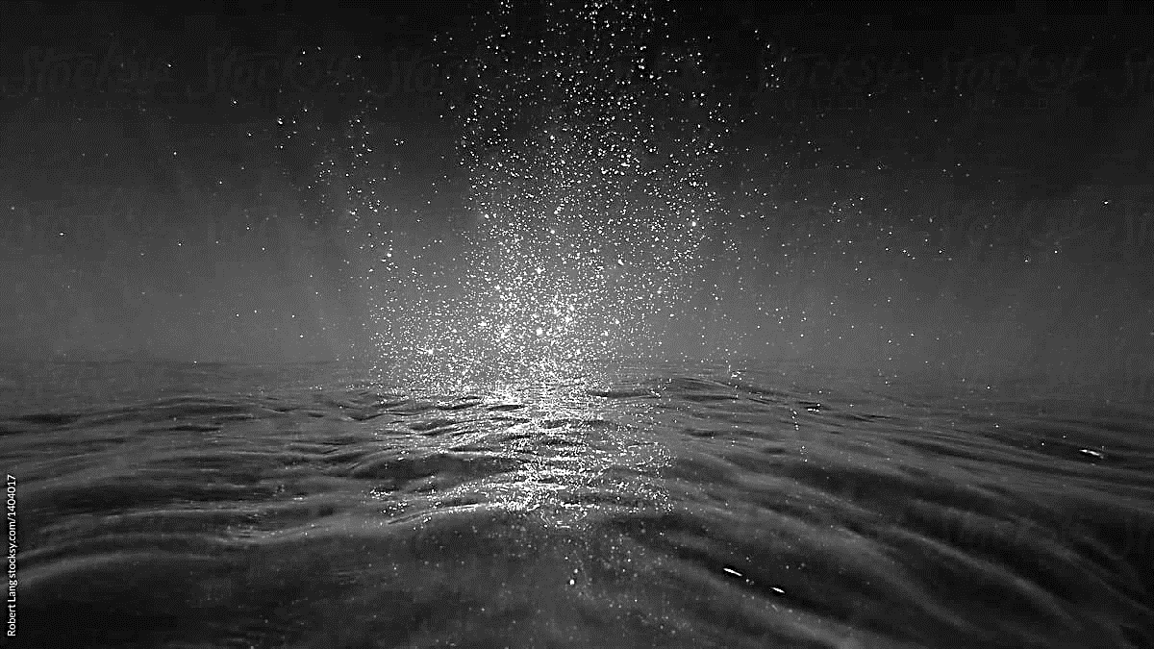
Transporters of Aquaculture Animals (WELLBOATS)

Application for registration

- Background
The Marine Institute is the Competent Authority responsible for the implementation of the aquatic elements of Regulation EU 2016/429 (Animal Health Law (AHL)) and it’s supplementing delegated and implementing Regulations.

- Obligations of transporters of aquatic animals
Certain obligations of transporters of aquatic animals concerning record keeping, biosecurity measures, water exchanges and labelling are set out in Article 188 of Regulation (EU) 2016/429 and in Articles 3, 4 and 5 of Commission Delegated Regulation (EU) 2020/990.

- Who should apply for wellboat registration?
In order for the Competent Authority to carry out official controls on transporters to ensure their compliance with Article 2(1)(a) of Regulation (EU) 2017/625 (Official Controls Regulation (OCR)) , and specifically with the Regulations referred to in paragraph 2 above, those transporters must be registered in accordance with Article 10 (2) of the OCR. The obligation to be registered applies to operators of wellboats that transport aquaculture animals.



- Particulars of Business

TRADE NAME

TRADE ADDRESS
CONTACT DETAILS | Landline: |  | Mobile:
 | Email:
BUSINESS STATUS  (Please Tick Relevant Box) | Limited Company Partnership  Sole Trader Cooperative
BUSINESS STATUS  (Please Tick Relevant Box) | Other
REGISTERED OFFICE ADDRESS
(if different from the trade address outlined above)
NAME OF APPLICANT

ADDRESS OF APPLICANT
CONTACT DETAILS | Landline: |  | Mobile:
CONTACT DETAILS | Email:

CONTACT NAME FOR ALL CORRESPONDENCE

ADDRESS TO WHICH ALL CORRESPONDENCE SHOULD BE SENT
(if different from the Registered Office Address outlined above)

- Provide Details of Vessel and Vessel Operations

NAME OF VESSEL

WELL CAPACITY OF VESSEL

REGISTRATION NUMBER OF VESSEL (IMO Number)
IDENTIFY VESSEL USE  (Please Tick Relevant Box(es)) | Transporter of Aquaculture Animals (Wellboat)
IDENTIFY VESSEL USE  (Please Tick Relevant Box(es)) | Other (please specify)
AQUACULTURE ANIMALS
(Provide details of species & estimation of quantities (numbers, volume or weight) of fish that may be transported at any given time)

- Declaration by Applicant

I/we declare that:

- The aquatic animals transported by this business are transported under conditions which neither alter their health status nor the health status of aquatic animals at the point of destination. Specifically, they are not loaded and transported in water that alters their health status and they are not transported in the same water as aquatic animals of a lower health status;
- The vessel is designed and constructed in such a way that cleaning and disinfection can be carried out effectively between consignments;
- The vessel and equipment used to transport the aquatic animals are thoroughly cleaned and disinfected between consignments using products of proven efficacy and according to the manufacturer’s instructions;
- The cleaning and disinfection referred to in point (iii), and the record keeping associated with that cleaning and disinfection, is carried out in accordance with the protocol set out in Annex I;
- Where the cleaning and disinfection system is automated, a maintenance log is kept in accordance with Annex 2;
- The transportation records referred to in Annex 3 are kept for all consignments transported;
- Only animals that show no disease symptoms and are fit for the journey, are transported;
- Where we suspect/ are aware of the presence of a listed disease, this suspicion/ knowledge will be reported immediately to the Marine Institute;
- Water exchanges take place only at a distance of 10km or more, from the nearest aquaculture establishment;
- The water exchanges referred to in point (ix) do not take place in areas which are subject to movement restrictions or emergency measures;
- All consignments transported are identified by means of an entry in the ships manifest, which clearly link to any animal health certificate which may apply to a given consignment;
- to the best of my/our knowledge, all particulars given in this application are correct and I/we undertake to inform the Marine Institute of any changes in particulars which might occur in the future

Signature of Applicant:

Date

Name (in block capitals)

Position

It should be noted that information provided by you may be subject to disclosure under the FOI Acts 1997 and 2003 and AIE Regulations 2007-2011. If you wish to have any of the records concerned protected under the Confidentiality, Commercially Sensitive, Personal Information or other exemption provisions of that legislation, you should mark those records accordingly and state your reasons. The relevant exemptions will then be considered in the event of a FOI or AIE request relating to those records.

ANNEX I
A. Stages of Cleaning and Disinfection

Stage | Under which circumstances should the stage be completed: | What does it entail: | Discharge of water during the cleaning & disinfection process:
1. | Stage 1 cleaning must be completed after every movement, and before contact with a new stock of fish.  Stage 1 is the basis for Stages 2 and 3. | Effective cleaning of the items listed in Part C.2.1. of Annex I | Water taken up at the site for cleaning, should either be discharged at the site, or at least 10km away from an active aquaculture establishment.
2. | At a minimum, Stage 2 cleaning & disinfection must be completed before a vessel:  - leaves a site in Ireland which is experiencing increased mortality;  - moves between aquaculture sites in Ireland*  *When shuttle runs are required to move a particular cohort of fish from one bay to another, Stage 2 is carried out before the first run, then at a minimum, Stage 1 cleaning is carried out after each subsequent run, until such time as the entire cohort of fish has been moved. | Complete Stage 1, and effective disinfection of the items listed in Part C.2.2. of Annex I | Water taken up at the site for disinfection, should either be discharged at the site, or at least 10km away from another active aquaculture establishment.
3. | Stage 3 cleaning & disinfection including the hull must be completed before a vessel, which has come from abroad, commences work on an aquaculture establishment in Ireland.  Once a Stage 3 cleaning & disinfection has been completed, the vessel should steer a course which keeps it at least 10km from the nearest aquaculture establishment, until it arrives at its destination. If this distance is not achievable, the vessel should maintain closed valve status (including ballast water), and steer a course at least 5km from the nearest aquaculture establishment. | Complete Stages 1 and 2, and slipping of the vessel, to ensure the hull below the waterline is cleaned and disinfected. | Stage 3 cleaning and disinfection can be performed at a port which is at least 10km from an active aquaculture establishment.

B. Paperwork and Notification Required

Stage | Approved by | Notify the Marine Institute
1. | Vessel cleaning checklist (Part C.2.1. of Annex I) completed and signed off by the Operator of the vessel and witnessed by another crew member (Part C.3. of Annex I).  The Operator of the vessel should retain a log of cleaning agents used on board and the dates on which those processes are carried out. | Not required when the vessel has already been working in Ireland.  When coming from abroad, submit Part C.3. of Annex 1 to the Marine Institute at notification@marine.ie with evidence of completion of Stages 2 & 3 at least 2 working days before the vessel arrives in Ireland.
2. | Vessel disinfection checklist (Part C.2.2. of Annex I) completed and signed off by the Operator of the vessel and witnessed by another crew member (Part C.4. of Annex I).  The Operator of the vessel should retain a log of disinfectants used on board and the dates on which those processes are carried out.  In addition, for vessels which have already been working in Ireland, before the vessel commences operations, the Fish Health Manager/Biologist of the site where the vessel is to be used must:  - be satisfied that cleaning and disinfection has been completed thoroughly. This includes checking the detailed records of cleaning and disinfection which are provided by the Operator of the vessel, and the completion of swab checks of relevant parts of the vessel, to ensure the biosecurity measures employed at the site are not jeopardised;  - visually check the hull of the vessel to ensure it is not heavily biofouled;  - sign Part C.5 of Annex I and complete the Farm Checklist for Vessels before the vessel can commence site operations; | Not required when the vessel has already been working in Ireland.  When coming from abroad, submit Part C.4. of Annex 1 to the Marine Institute at notification@marine.ie with evidence of completion of Stages 1 & 3 at least 2 working days before the vessel arrives in Ireland.

Stage | Approved by | Notify the Marine Institute
3. | Cleaning and disinfection must be supervised by a veterinarian. Part C.6. of the Marine Institute’s Cleaning and Disinfection Declaration (C-038) must be completed once the veterinarian is satisfied that all 3 stages of cleaning and disinfection have been appropriately executed and fully completed.  The Operator of the vessel should retain a log of cleaning, disinfecting and slipping the vessel and the dates on which those processes are carried out.  In addition, for vessels coming to Ireland from abroad, before the vessel commences operations, the Fish Health Manager/Biologist of the site where the vessel is to be used must:  - be satisfied that cleaning and disinfection has been completed thoroughly. This includes checking the detailed records of cleaning and disinfection which are provided by the Operator of the vessel, and the completion of swab checks of relevant parts of the vessel, to ensure the biosecurity measures employed at the site are not jeopardised;  - visually check the hull of the vessel to ensure it is not heavily biofouled;  - sign Part C.5 of Annex I and complete the Farm Checklist for Vessels before the vessel can commence site operations; | When coming from abroad, submit Part C.6. of Annex 1 to the Marine Institute at notification@marine.ie with evidence of completion of Stages 1, 2 & 3 at least 2 working days before the vessel arrives in Ireland.

C. Cleaning and Disinfection Declaration (C-038)

C.1. PRODUCT / EQUIPMENT DETAILS:
Name of detergent used
Water Temperature used
Name & concentration of disinfectant used
Other equipment used (specify)

C.2. CLEANING & DISINFECTION CHECKLIST:
C.2.1.  STAGE 1 CLEANING | TICK | C.2.2.  STAGE 2 DISINFECTION | TICK
Hull above waterline |  | Hull above waterline
Wells |  | Wells
Grid plates |  | Grid plates
Pumps (incl. vacuum pump |  | Pumps (incl. vacuum pump
Bilge pumps |  | Bilge pumps
Sea valves |  | Sea valves
Deck |  | Deck
Railings |  | Railings
Bulkhead/casings |  | Bulkhead/casings
Hatches and covers |  | Hatches and covers
Derrick |  | Derrick
Crane |  | Crane
Ladders |  | Ladders
Counting Table |  | Counting Table
Ballast Tanks |  | Ballast Tanks
Protective clothing & boots |  | Protective clothing & boots
Date Completed |  | Date Completed

C.3. DECLARATION TO BE COMPLETED BY OPERATOR OF VESSEL AFTER STAGE 1 CLEANING:
I, …………………………………. Operator of the ……………………………………………have overseen the cleaning procedures outlined above and can confirm that they have been carried out in accordance with the requirements of the Marine Institute.
SIGNED: ____________________________ DATE: ______________________
WITNESSED: _________________________ DATE: ______________________

C.4. DECLARATION TO BE COMPLETED BY OPERATOR OF VESSEL AFTER STAGE 2 DISINFECTION:
I, …………………………………. Operator of the ……………………………………………have overseen the disinfection procedures outlined above and can confirm that they have been carried out in accordance with the requirements of the Marine Institute.
SIGNED: ____________________________ DATE: ______________________
WITNESSED: _________________________ DATE: ______________________

C.5. FISH HEALTH MANAGER/BIOLOGIST DECLARATION TO BE COMPLETED EACH TIME A VESSEL ARRIVES AT A SITE TO COMPLETE A TREATMENT/ HARVEST:
I, ………………………… the undersigned Fish Health Manager/ Biologist have inspected the cleaning / disinfection and travel records of the above vessel, prior to the commencement of operations on the above site, and confirm that to the best of my knowledge, this vessel complies with the requirements of the Marine Institute.

SIGNED: ________________________________
DATE: ________________________________

C.6. VETERINARY DECLARATION TO BE COMPLETED AFTER STAGE 3 CLEANING & DISINFECTION:
I, …………………………………. the undersigned veterinarian, have overseen the cleaning and disinfection referred to in the Cleaning & Disinfection checklist above, in addition to the cleaning and disinfection of the vessel’s hull below the waterline, and I have verified that all 3 stages of cleaning and disinfection have been appropriately executed and fully completed in accordance with the requirements of the Marine Institute.

SIGNED: ________________________________

DATE: ________________________________

POSITION &
NAME OF COMPANY: _______________________________________________

ANNEX 2

Maintenance Log

A maintenance log should be kept for all repair and maintenance works carried out on vessel equipment by company personnel or external contractors.

At a minimum, the log should contain details on:
- Date
- Details of maintenance/ repair work carried out
- Name of the person/ company who completed the work
- Any additional comments

This log must be made available for inspection by the Marine Institute, on request.

ANNEX 3

Transportation Records

Transportation records must be kept for the vessel, including at least the following information for each consignment:

- Date and time of loading

- Name and address of the site of origin

- Species transported

- Number of fish transported

- Volume/weight of fish transported

- Date and time of unloading

- Name and address of the establishment of destination

- Details of observed mortality during the journey (number of animals and general observations)

- Details of the route taken by the vessel including aquaculture establishments and disease control aquatic food establishments visited by the vessel

- Any exchange of water which took place during transport, specifying where water exchanges took place.

OJ L 84, 31.3.2016, p.1.
OJ L 221, 10.7.2020, p.42.
OJ L 95, 7.4.2017, p. 1-142.

